https://www.youtube.com/watch?v=r8OjlgWpAI0

How logistic regression is computed:

- Step-by-Step Procedure for Logistic Regression
1. Define the Problem
- Logistic regression is used for classification, typically binary (e.g., Yes/No, 0/1).
- Example: Predicting whether an email is spam (1) or not spam (0).

2. Prepare the Data
- Collect input features (x₁,x₂,………..x_{n}).
- Define the target variable (y) which is categorical (binary or multinomial).
- Normalize or scale features if needed.

3. Formulate the Model
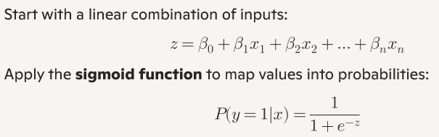
4. Define the Loss Function
- Use log-likelihood (cross-entropy loss):
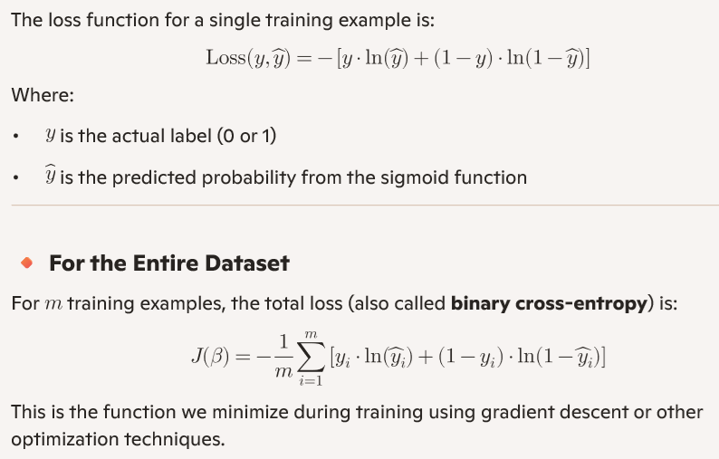
- The goal is to maximize this likelihood (or equivalently minimize the negative log-likelihood).

5. Estimate Parameters
- Parameters (Beta)) are estimated using Maximum Likelihood Estimation (MLE).
- Optimization is typically done with:
  - Gradient Descent
  - Newton-Raphson method

6. Train the Model
- Iteratively update coefficients until convergence:
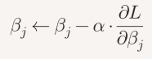
- where (Alpha) is the learning rate.

7. Make Predictions
- Compute probability:
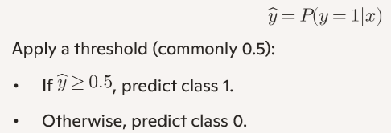

8. Evaluate the Model
- Use metrics like:
  - Accuracy
  - Precision, Recall, F1-score
  - ROC curve & AUC

Summary
Logistic regression transforms a linear equation into a probability using the sigmoid function, estimates parameters via maximum likelihood, and classifies outcomes based on a threshold. It’s widely used because it’s interpretable and efficient for binary classification tasks.

Example:
We’ll use a tiny dataset with one feature (x) and binary target (y):
Observation | (x) | (y)
1 | 0 | 0
2 | 1 | 1
We want to fit a logistic regression model:
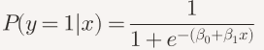q

🔹 Step 1: Initialize Parameters
Let’s start with:
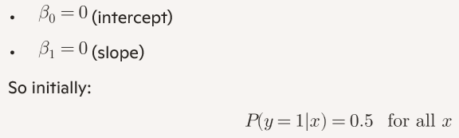
🔹 Step 2: Compute Log-Likelihood
The log-likelihood is:
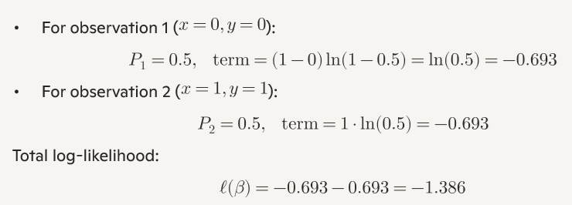

🔹 Step 3: Compute Gradients
Gradient for each parameter:
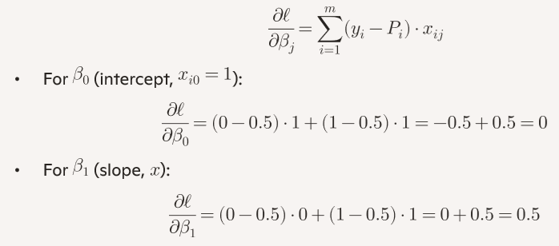
🔹 Step 4: Update Parameters
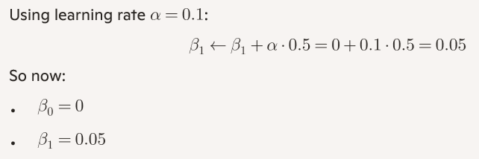
🔹 Step 5: Recompute Probabilities
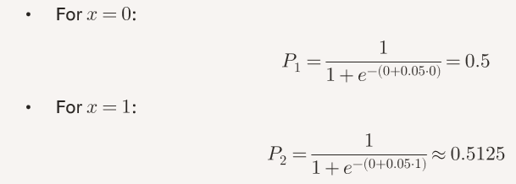
So the model is starting to shift toward predicting (y=1) when (x=1).

Summary
- We initialized parameters at zero.
- Computed log-likelihood ((-1.386)).
- Found gradient updates ((\partial \ell/\partial \beta_1 = 0.5)).
- Updated slope to (0.05).
- Probabilities adjusted slightly toward the correct classification.

